
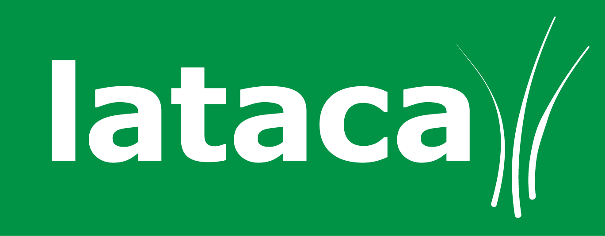
Summer Term 6 - Lunch Menu Order Form
Please ensure this order form is returned to school by
9am on Thursday the 23rd May, you can also email it to us at Info@lataca.co.uk by the 23rd May.

Key Stage 1 meals are free of charge
Key Stage 2 meals are £2.25 a day

The total cost for the whole term is £85.50

Our BACS details are as follows – Sort Code: 52-30-27
Account Number: 35619945 (if paying by BACS please include the date of payment)

Child’s Name
Child’s Class |  | Key Stage | 1 or 2
Child’s School | Aloeric

 | Menu | Mon | Tues |  | Wed | Thurs | Fri
Week commencing 03rd Jun | 1
Week commencing 10th Jun | 2
Week commencing 17th Jun | 3
Week commencing 24th Jun | 1
Week commencing 01st July | 2 | X
Week commencing 08th July | 3
Week commencing 15th July | 1
Week commencing 22nd July | 2 |  |  |  |  |  | X
Total number of meals
Amount enclosed |  | £
Method of payment  Please Circle! |  | FSM KS1  FSM KS2 |  | BACS  Date of Bacs  Payment:  ……………………….. |  | Cheque | Cash

Hot meal | A
Jacket potato | C
Salad, Soup or Sandwich | E
Vegetarian meal | G
School Closed | X | Special Meal | S

