
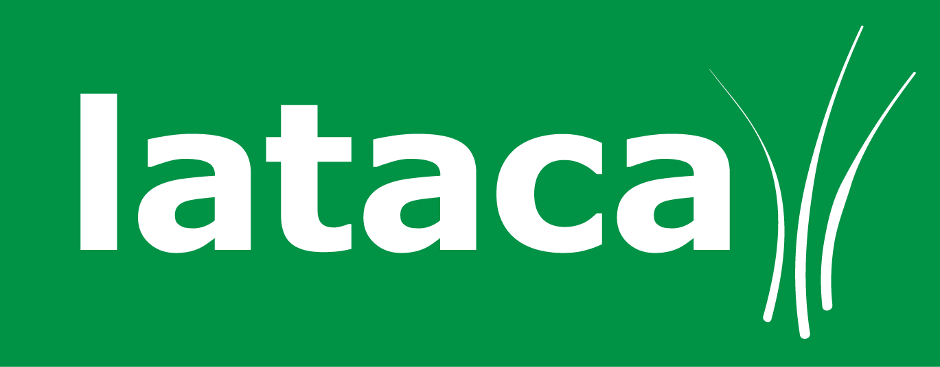
Spring Term 3 - Lunch Menu Order Form
Please ensure this order form is returned to school by
9am on Thursday the 13th December, you can also email it to us at Info@lataca.co.uk by the 13th December

Key Stage 1 meals are free of charge.
Key Stage 2 meals are £2.25 a day.

The total cost for the whole term is £65.25

Our BACS details are as follows – Sort Code: 52-30-27
Account Number: 35619945 (if paying by BACS please include the date of payment)

Child’s Name
Child’s Class |  | Key Stage | 1 or 2
Child’s School | Aloeric

 | Menu | Mon | Tues |  | Wed | Thurs | Fri
Week commencing 07th Jan | 1 | X
Week commencing 14th Jan | 2
Week commencing 21st Jan | 3
Week commencing 28th Jan | 1
Week commencing 4th Feb | 2
Week commencing 11th Feb | 3
Total number of meals
Amount enclosed |  | £
Method of payment  Please Circle! |  | FSM KS1  FSM KS2 |  | BACS  Date of Bacs  Payment:  ……………………….. |  | Cheque | Cash

Hot meal | A
Jacket potato | C
Salad, Soup or Sandwich | E
Vegetarian meal | G
School Closed | X | Special Meal | S

