
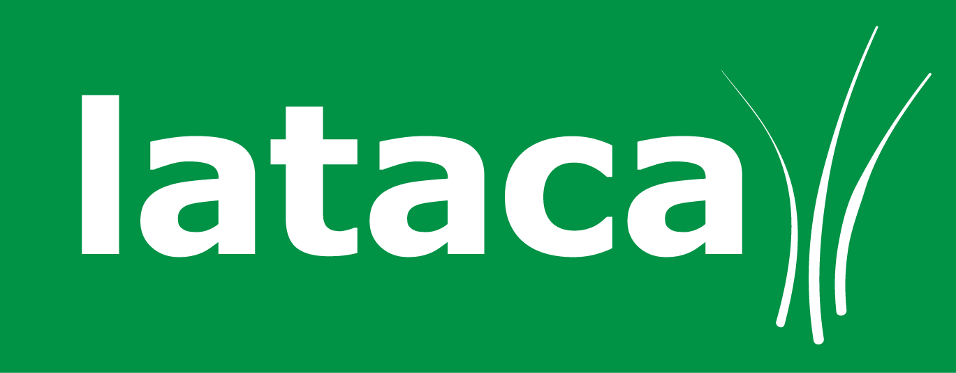
Spring Term 4 - Lunch Menu Order Form
Please ensure this order form is returned to school by
9am on Thursday the 7th February, you can also email it to us at Info@lataca.co.uk by the 7th February.

Key Stage 1 meals are free of charge, juice is charged at 45p per day
Key Stage 2 meals are £2.25 a day, juice is charged at 45p per day

The total cost for the whole term is £66.50 without juice and £79.10 with juice, these prices include the Easter meal.

Our BACS details are as follows – Sort Code: 52-30-27
Account Number: 35619945 (if paying by BACS please include the date of payment)

Child’s Name
Child’s Class |  | Key Stage | 1 or 2
Child’s School | Aldbourne

 | Menu | Mon | Tues |  | Wed | Thurs | Fri
Week commencing 25th Feb | 1
Week commencing 4th Mar | 2
Week commencing 11th Mar | 3
Week commencing 18th Mar | 1 | X
Week commencing 25th Mar | 2
Week commencing 1st Apr | 3 |  |  |  | S
Total number of meals
Amount enclosed |  | £
Method of payment  Please Circle! |  | FSM KS1  FSM KS2 |  | BACS  Date of Bacs  Payment:  ……………………….. |  | Cheque | Cash

Hot meal without juice | A | Hot meal with juice | B
Jacket potato without juice | C | Jacket potato with juice | D
Salad, Soup or Sandwich | E | Salad, soup or sandwich with juice | F
Vegetarian meal without juice | G | Vegetarian meal with juice | H
School Closed | X | Special Meal | S

